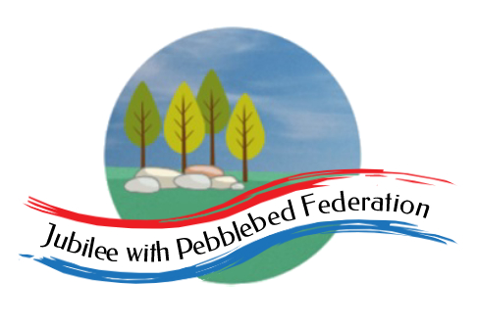
The Jubilee Hub of The Jubilee with Pebblebed Federation
Subject Intent Statement for Computing
Our Vision
‘Be who God meant you to be and you will set the world on fire.’
St Catherine of Siena
Intent
In the Jubilee Hub of the Jubilee with Pebblebed Federation, we feel our curriculum should be giving children real experiences and preparing them for life. We believe that computing is an essential part of the curriculum; a subject that not only stands alone but is woven and should be an integral part of all learning. Computing, in general, is a significant part of everyone’s daily life and children should be at the forefront of new technology, with a thirst for learning what is out there. Computing within schools can therefore provide a wealth of learning opportunities and transferrable skills explicitly within the Computing lesson and across other curriculum subjects.

Through the study of Computing, children will be able to develop a wide range of fundamental skills, knowledge and understanding that will actually equip them for the rest of their life. Computers and technology are such a part of everyday life that our children would be at a disadvantage if they were not exposed to a thorough and robust Computing curriculum. Children must be given opportunities to develop their skills and knowledge in order to provide them with essential knowledge that will enable them to participate effectively and safely in the digital world beyond our gates.
Implementation
In the Jubilee Hub of the Jubilee with Pebblebed Federation, computing is taught using a thematic cross curricular approach. This ensures children are able to develop depth in their knowledge and skills over the duration of each of their computing topics. Teachers use the Cornerstones Curriculum as a starting point for the planning of their computing lessons, which are often richly linked to engaging contexts in other subjects and topics. A clear skills progression is also followed to ensure learning is developmental.

The children in our Early Years’ provision will be exposed to the understanding of internet safety as they explore the world around them and how technology is an everyday part of their learning and understanding of the world.

In Key Stage 1 the children will learn to understand what algorithms are; how they are implemented as programs on digital devices; and that programs execute by following precise and unambiguous instructions. They will be taught to create and debug simple programs and use logical reasoning to predict the behaviour of simple programs. They will be shown how to use a range of technology purposefully to create, organise, store, manipulate and retrieve digital content as well as recognise common uses of information technology beyond school. They will be taught to use technology safely and respectfully, keeping personal information private; identify where to go for help and support when they have concerns about content or contact on the internet or other online technologies. Each of these skills will be taught through exciting half termly units.

In Key Stage 2 the children will design, write and debug programs that accomplish specific goals, including controlling or simulating physical systems; solve problems by decomposing them into smaller parts. They will use sequence, selection, and repetition in programs, use logical reasoning to explain how some simple algorithms work and correct errors in algorithms and programs. Children will be taught to understand computer networks, including the internet, and the opportunities they offer for communication and collaboration. They will use search technologies effectively, learn to appreciate how results are selected and ranked, and be discerning in evaluating digital content. Children will be taught to select, use and combine a variety of software on a range of digital devices to create a range of programs, systems and content that accomplish given goals. They will use technology safely, respectfully and responsibly; recognise acceptable/unacceptable behaviour; identify a range of ways to report concerns about content and contact.

Intended Impact
By the time children leave our schools they will be digitally literate and able to join the rest of the world on its digital platform. They will be equipped, not only with the skills and knowledge to use technology effectively and for their own benefit, but more importantly – safely. The biggest impact we want on our children is that they understand the consequences of using the internet and that they are also aware of how to keep themselves safe online.

As children become more confident in their abilities in Computing, they will become more independent and key life skills such as problem-solving, logical thinking and self-evaluation become second nature.

