3rd March 2023

Dear Parents,

Last Friday, Class 1 went to Woodbury Salterton to experience a planetarium in a Space Dome. The day started off with a fantastic presentation inside the Space Dome. The children learnt about the planets and were then treated to a fantastic show of the stars at night. It was extremely dark inside the Space Dome and some of us were a little nervous about this! Afterwards, we worked on our knowledge of colour and the colour wheel in school, copying pictures of some of our favourite planets and constellations. What a fantastic day!

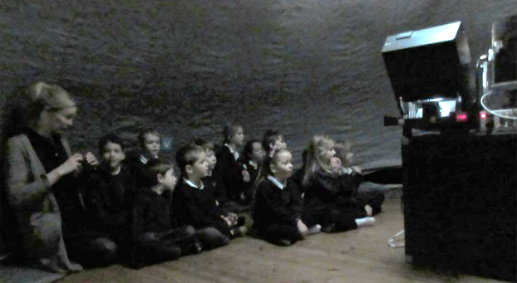

Class 1 are working really hard on their science and design and technology this half term. In science they will be working out the best materials to create an air-propelled rocket and then will be testing their creations. In design and technology, the children will read the story of ‘Man on the Moon’ by Simon Bartram. Bob - the man on the moon- also works on the moon, keeping it clean, showing tourists around and selling souvenirs. However, he has a lot to carry and needs some help. The children have been asked to design and make a moon buggy to help Bob with his work. Once the children have made their rocket and their moon buggy, they will need help testing and evaluating their work. This is where you come in. We will be having a testing and evaluation afternoon to which you will be invited on Thursday 30th March at 2pm - details to follow.

Over the last few weeks, Class 2 have enjoyed designing and making a Mexican banquet, and constructing and painting colourful ‘Day of the Dead’ masks from ‘Modroc’. Our sharing assembly together was also a lovely end to the half term.

In Literacy, Class 2 studied explanation texts, which gave them a great opportunity to develop their research skills and link their design and technology and art to writing about ‘Day of the Dead’ celebrations and indigenous Mexican animals.

Class 2’s older boys also had the opportunity to play local schools in a futsal football tournament with Honiton Learning Community. We are proud to say that they tied for first place on equal points, but unluckily just dipped out on goal difference. Highlights included Josh saving a penalty and scoring three goals; Max scoring a penalty and making a string of saves in a one-nil win; prolific Tyler scoring six goals; Oscar racing box to box as he linked attack and defence; Alfie and Charlie’s commanding defensive performances and most importantly a great cohesive team performance. They finished the tournament with a table topping 3 wins and just 1 defeat. Well done to them!

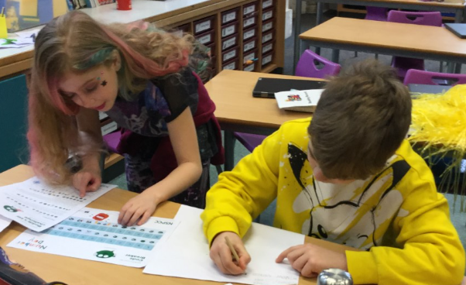
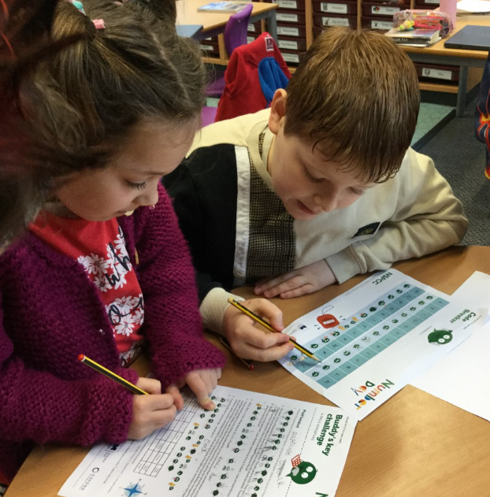
The children enjoyed taking part in the NSPCC Number Day, when they dressed as Times Table Rock Stars. They also spent the day solving maths problems and completing maths quizzes and challenges. A highly competitive group activity saw children working together to solve challenging problems.

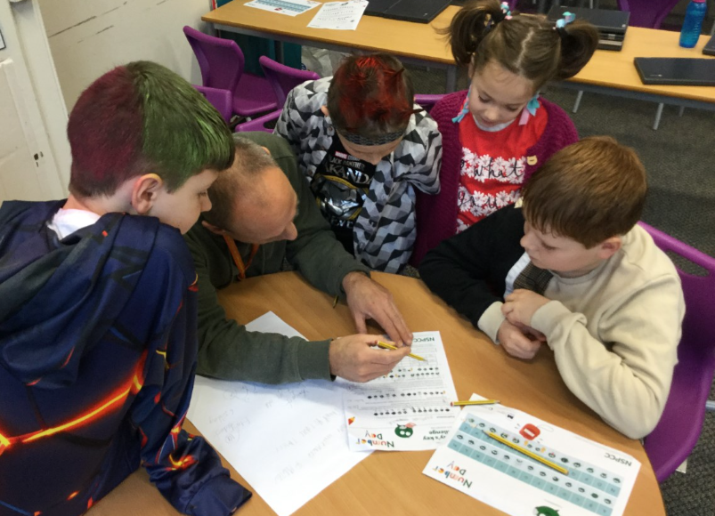
Thank you all for your continued support.
God bless and have a lovely weekend.
Best wishes from Katie Gray and the staff at Broadhembury CE School
BROADHEMBURY BRIDGES
Class 1:
Albie - for being such a good learner all week.
Bob - for being such an excellent learner on our trip this week.
Class 2:
Max - for being a good learner and for being respectful and considerate.
Alicia - for being a good learner and always showing her best.
Alfie - for being a good learner and always showing his best.

Question of the month

Class 1 - Think of a name for a made up planet. Why have you given your planet this name?

Class 2 - What qualities make a great team?

Key Dates – Spring Term 2023
Tuesday 14th March- Year 3 and 4 Tag Rugby Event.
Friday 17th March - Class 2 Devon school games - Dance day.
Monday 20th March- Red Nose day.
Wednesday 22nd March – Parents’ Evening. (A letter has been sent out with more information)
Thursday 30th March - Class One Parents’ Afternoon - 2pm.
Friday 31st March- Last day of term.
Monday 17th April- Back to school.

Red Nose Day
This year we will hold Red Nose Day on Monday 20th March. The children are welcome to come to school on this day wearing a red nose and bring in a donation for charity, if they are able. Red Noses will not be allowed on Friday 17th March, as Class 2 will be out on a trip. Thank you for your support.

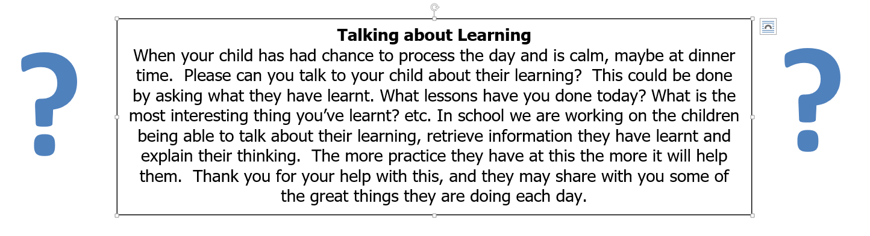

Reminders:

Recycling
Please could you send in any recycling for the children to use in our making area. Things like plastic bottles, cardboard boxes, kitchen roll holders etc. would be great! Thank you.

School Uniform
Please can you ensure that your child has all their uniform named. It really helps at the end of the day to ensure that the correct jumper is returned to the correct child. Also, as the weather gets colder, please can you ensure that your child has a warm coat and that any hats, gloves etc. are named. Thank you for your help.

School Bus
We have had a request from the bus company that brings the children to school from Dunkeswell, please can parents not park in the bus stop to enable the bus to be able to park and the children to get off the bus safely. Thank you for your co-operation.

Toys
Please can we request that the children do not bring in toys or stickers from home. These often get lost or damaged and cause distractions for the children during the day. Thank you.

Free School Meals
If your circumstances have recently changed your child may have become eligible for free school meals. This will also bring extra funding to the school, which will be used to help your child. For an instant decision or to learn more please go online at https://www.devon.gov.uk/educationandfamilies/school-information/school-meals.

Sharing Assembly
Sharing assembly will continue each Friday afternoon at 3pm. All parents/carers are invited to come and see the children sharing their learning.

Wellbeing
There has been much press in recent months about children’s mental health. As part of our drive to support this we are going to include something each month in the newsletter about Health and Wellbeing. We hope you find this section useful. If you have any topics you would like us to find some helpful tips about, please let us know.

The BBC have produced a Mental Health Toolkit called Headroom. This has been set up to give you tools to help with troubles surrounding mental health. Whether it is everyday tips, sounds to relax your mind, strategies to cope with parenting right now or films to get you talking, the BBC are there to help you look after yourself and your loved ones. As the children return to school next week it is worth having a look at the section on sleep to help them through busy days. Follow the link below to find all of the toolkit and resources for adults and children.

https://www.bbc.co.uk/programmes/articles/YfRzhXDKSZQxFVn30TlXBj/your-mental-health-toolkit

Collective Worship Activity
This term we will be focussing in school on the value of Service. We hope your family will find these ideas helpful as you explore the value and have fun together. If the children bring back something that you have done at home linked to the Collective Worship activity, or can talk about a discussion they’ve had at home linked to it, then Mrs Gray will award them with a new special sticker.

