Broadhembury Church of England Primary School
Honiton
Devon
EX14 3NF
Executive Headteacher: Mrs Katie Gray
(01404) 841304
admin@broadhembury.devon.sch.uk www.broadhembury.devon.sch.uk

4th November 2022
Dear Parents,

Class 1 had a fantastic time visiting Axe Valley Wildlife Park last half term. They used their map skills to navigate the park and were able to read the key to find out where different attractions were. The animal handling workshop was a fantastic experience and many of the children were keen to touch and handle the giant millipede, the pythons, lizards and Archie the armadillo. The children learnt about animals from all over the world, but particularly focused on animals from Africa, spotting all types of mongoose and hand-feeding the meerkats. The children were engaged and excited and were exhausted after a really great day of learning.

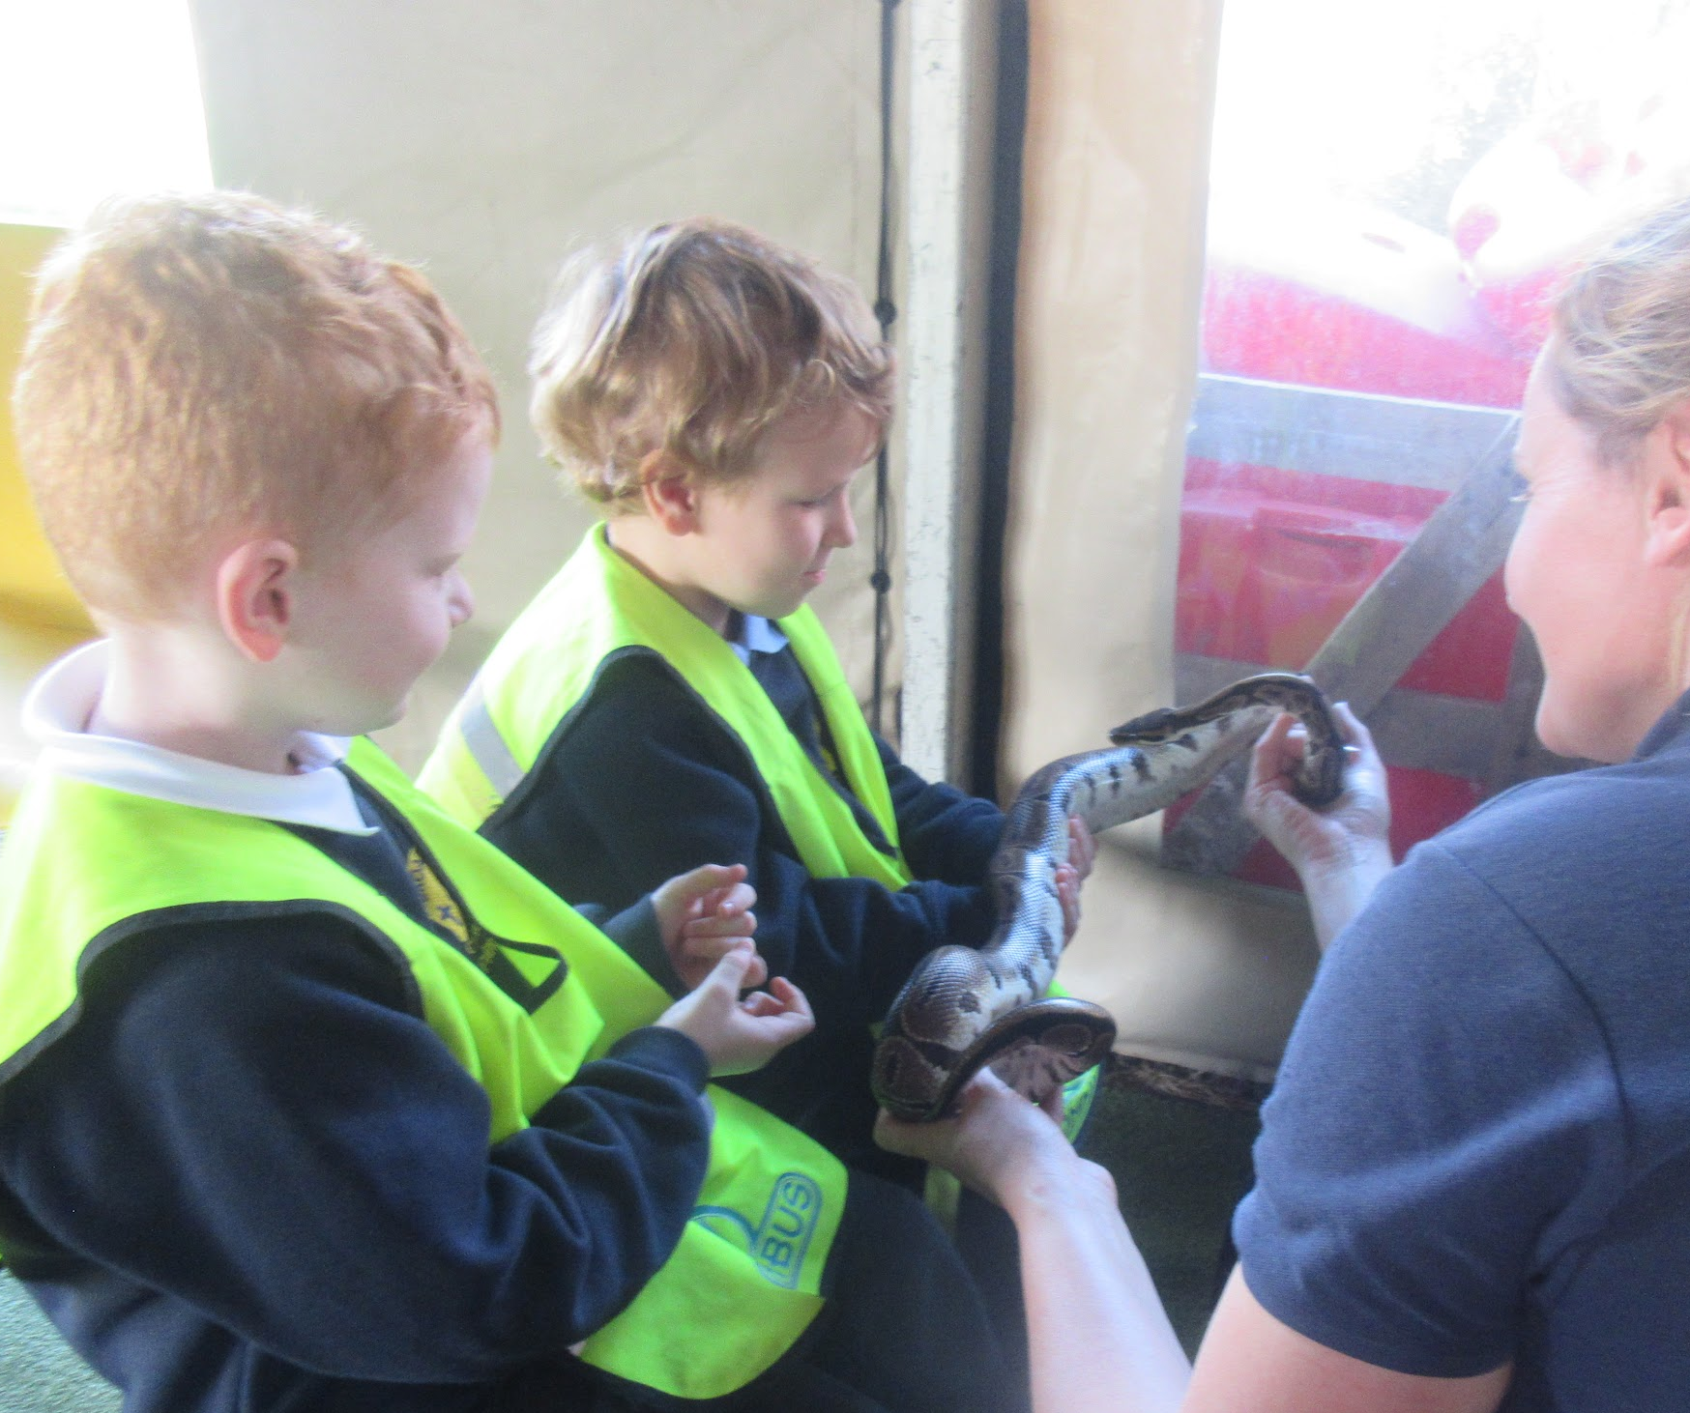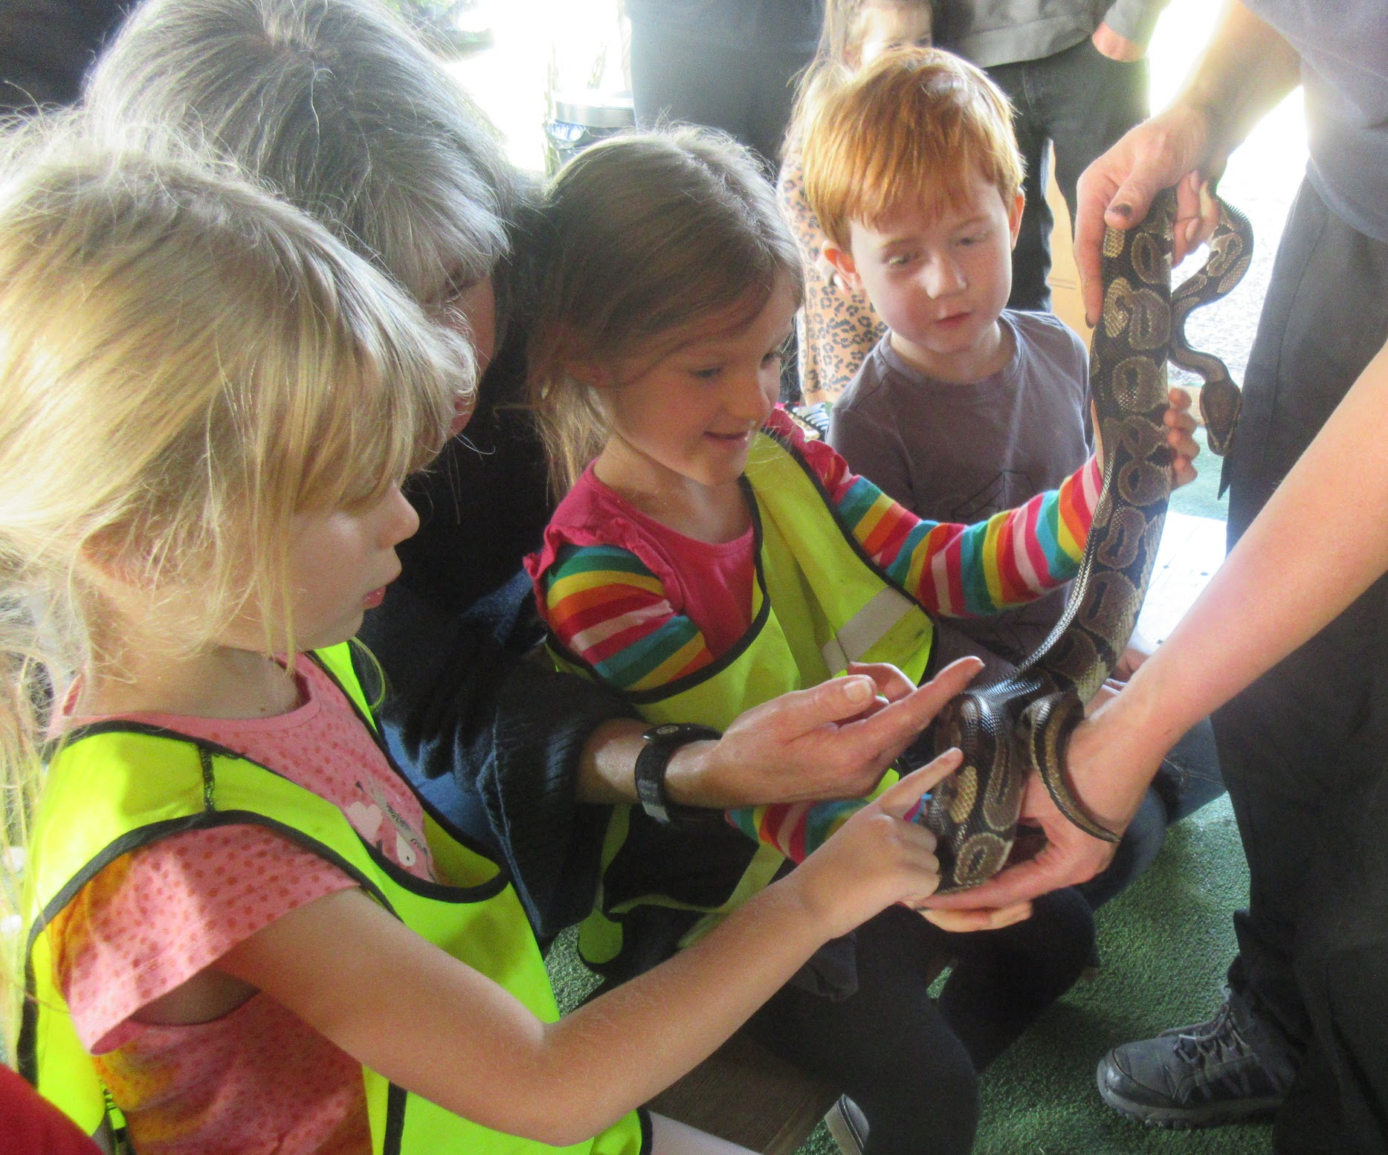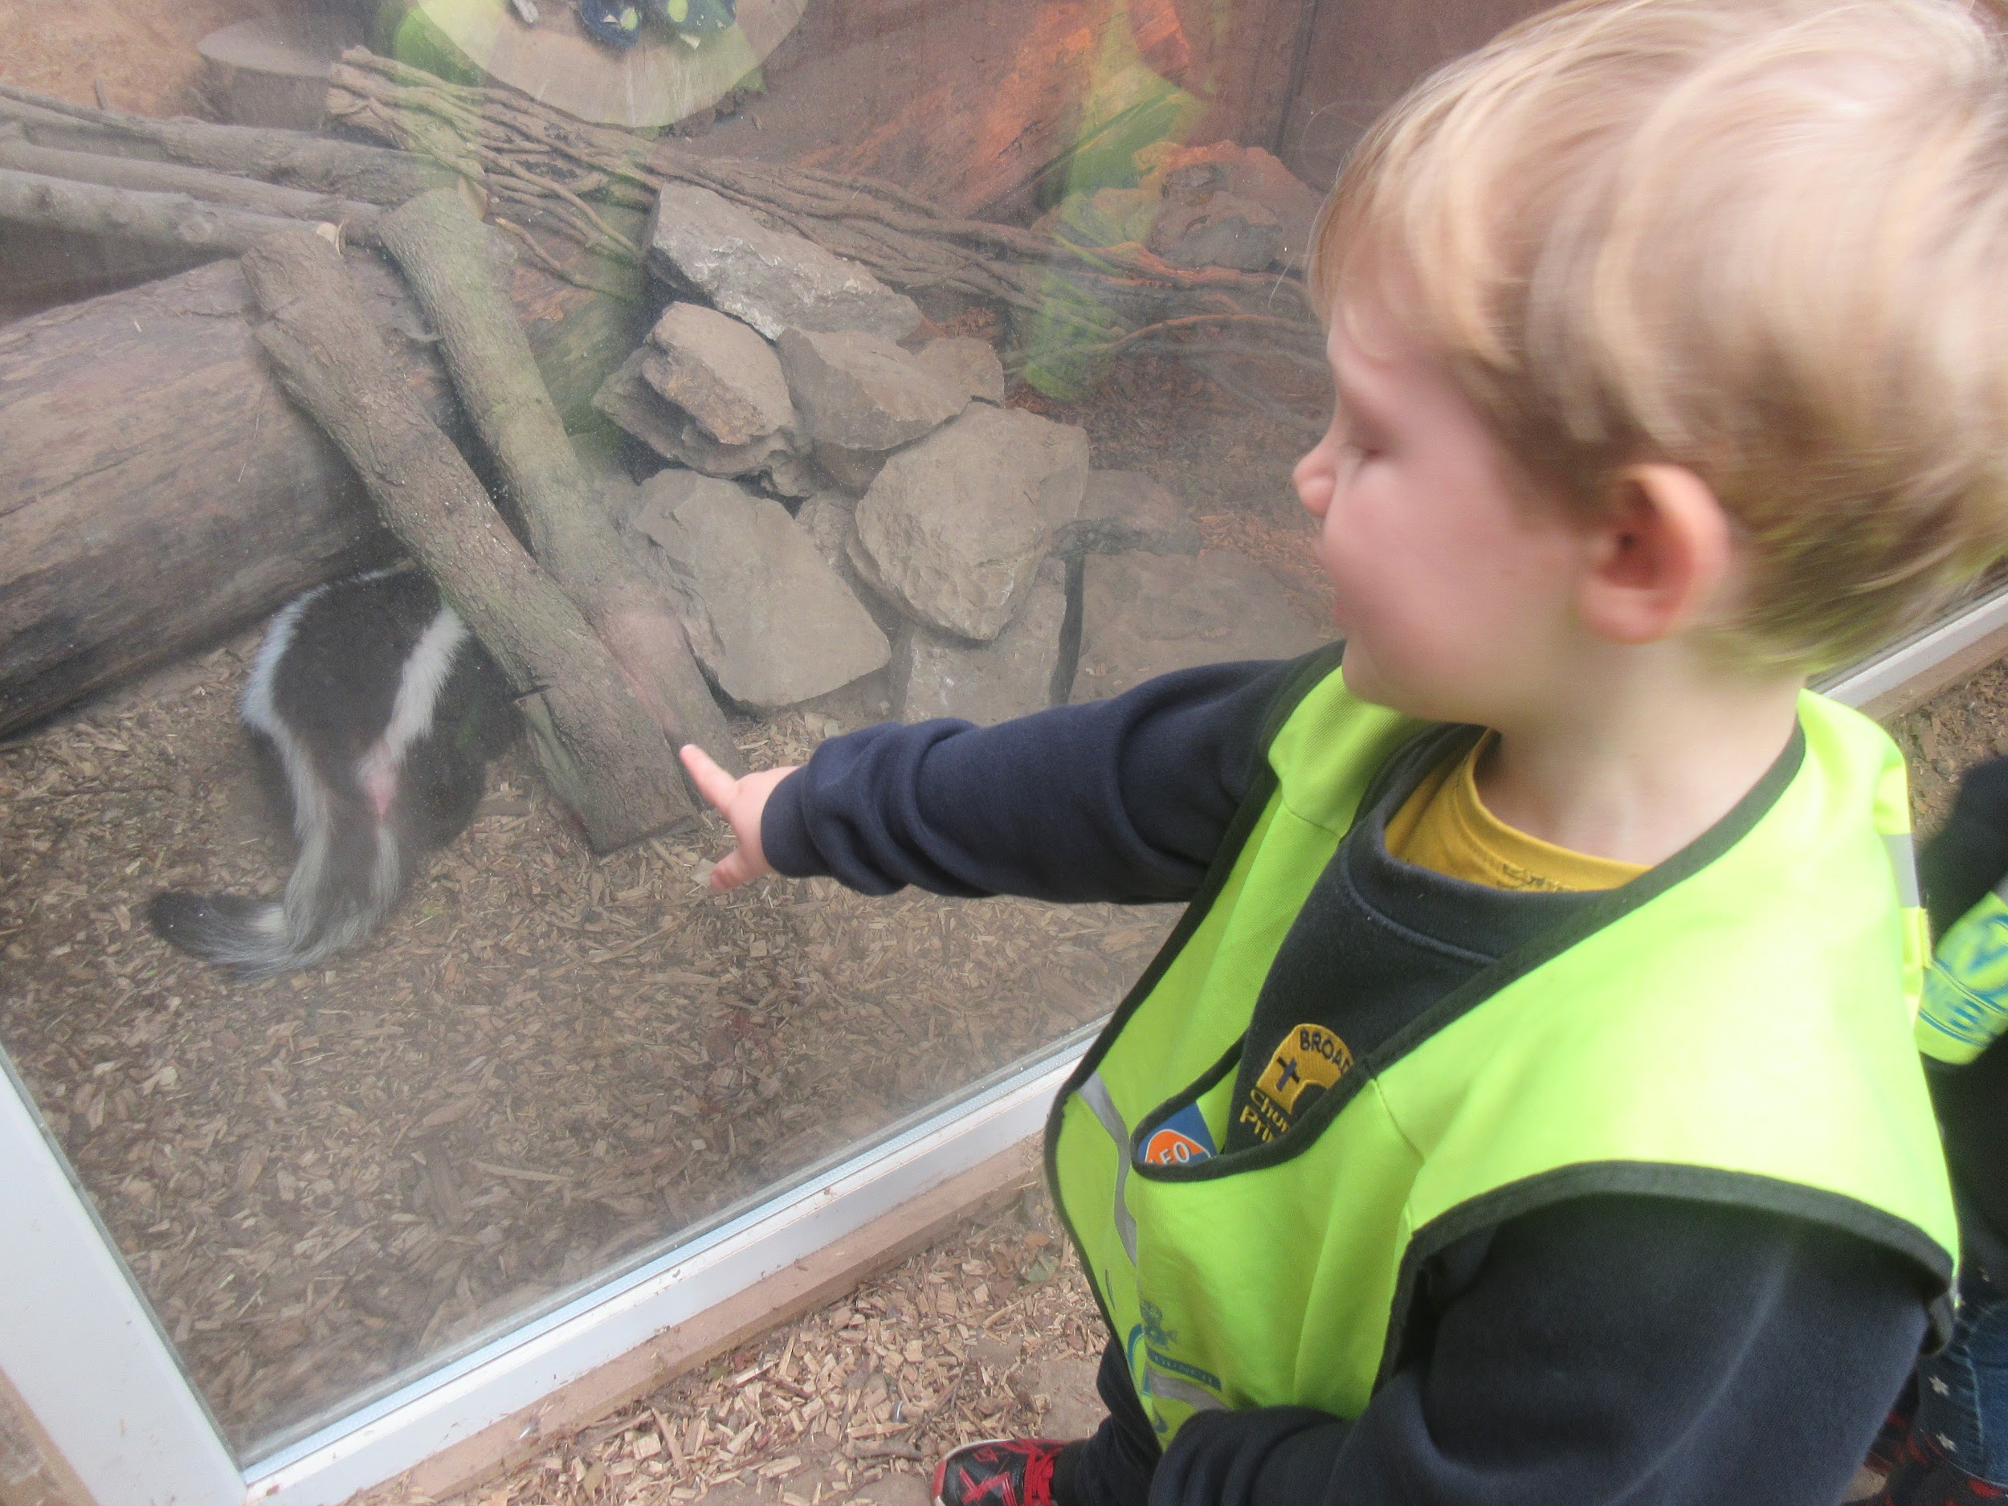

This half term, the Class 1 children are designing, making and evaluating a model of an imaginary pet, using recycled materials. Please could you begin saving plastic bottles, cardboard tubes, small cardboard boxes and plastic food trays. We will be sending an invitation home in due course, for you to come into school and admire the children’s hard work this term over a mince pie and a cup of tea. Look out for an invitation coming home soon.

Class 1 are also working hard on their phonics and reading. Please continue reading at home with your child as often as you can. Your child will be able to read their decodable Bug Club book to you. Please also share the library book with your child. We do not expect them to be able to read this independently. Please read our Phonics Statement on the school website for more information, Broadhembury C of E Primary School - Curriculum Statement (and individual subject information including phonics).

As part of our home learning policy, we will be sending home a small homework activity each week for children in Year 1. It will cover an area of Maths or English that we have been working on in class and your children should be able to complete it fairly independently. If you would like to know more, the home learning policy can be found on our website.

Class 1 have worked hard on their colour mixing this half term and will be using it to create a clay animal, as part of their independent challenges, at the end of this half term. In science the children will be looking at habitats this half term and exploring animal habitats around the school.

In Class 2 students finished their World War 2 diaries and published them in a beautiful class book. By studying an R.S.P.B. appeal letter, they then began to learn about persuasive writing this will continue over the next few weeks and we look forward to sharing this with you in sharing assembly.

In science class 2 are learning about forces and have started to investigate magnets, please talk to the children about the question of the months about magnets as this will help them with their learning.

Children have enjoyed working on the computer program ‘Scratch’ they have been writing programs for movement and animation this will lead onto the children writing programs for their own games.

The last month has also had a strong sporting theme, the children concluded their weekly swimming sessions where they worked hard to improve their water confidence and their swimming techniques. Years 3 and 4 have also visited Honiton Community College to take part in dance and gymnastic activities, staff have been really impressed with how the children work hard to achieve in these sessions and represent the school with pride.

Thank you all for your continued support.
God bless and have a lovely weekend.
Best wishes from Katie Gray and the staff at Broadhembury CE School
BROADHEMBURY BRIDGES
Class 1: Well done to all of the children this month who achieved a Broadhembury Bridge Award. Your learning behaviours have been exemplary.

Class 2: Conor – For being thoughtful and caring towards others.
Oscar – For always being ready to learn and being respectful and considerate to other learners.
Tyler – Being a good learner and working hard, achieving great results in times table learning.
Question of the month

Class 1: Do you have to be old to be wise?

Class 2: How are magnets used around the house?

Key Dates
8th November - Year 5 & 6 Gymnastics at H.C.C.
11th November - Remembrance Day.
14th November - Anti Bullying Week and KS2 Science at H.C.C.
16th November - Individual School Photos.
18th November - Flu Vaccinations.
18th November – Children in Need.
22nd November - Year 5&6 Sports Hall Athletics at H.C.C.
28th November - KS1 Science at H.C.C.
29th November - KS1 Multi-sports.
13th December - Christmas Play - 5.30pm.
16th December - Carol Singing in the square.

Reminders:
School Uniform
Please can you ensure that your child has all their uniform named. It really helps at the end of the day to ensure that the correct jumper is returned to the correct child. Also, as the weather gets colder, please can you ensure that your child has a warm coat and that any hats, gloves etc. are named. Thank you for your help.

Toys
Please can we request that the children do not bring in toys or stickers from home. These often get lost or damaged and cause distractions for the children during the day. Thank you.

Free School Meals
If your circumstances have recently changed your child may have become eligible for free school meals. This will also bring extra funding to the school, which will be used to help your child. For an instant decision or to learn more please go online at https://www.devon.gov.uk/educationandfamilies/school-information/school-meals.

Children in need
On Friday 18th November we will be supporting Children in Need. The theme this year is SPOTacular so we are inviting children to come into school dressed in spots. We are also asking the children to think about what makes them SPOTacular. Class One children can work with you to think of words and phrases that describe them and that make them special and Class Two can put together a presentation in the form of a piece of writing, poster, pictures, or computer presentation which explains what makes them special and SPOTacular. We will look at these on Children in Need day. We are also asking for a £1 donation from any families who would like to donate to the charity.
Sharing Assembly
We are pleased to be starting sharing assembly again after it was stopped due to COVID restrictions. This happens on a Friday afternoon at 3pm. All parents/carers are invited to come and see the children sharing their learning of the week, we look forward to inviting you all back to school.

Remembrance day
On Friday 11th November at 10.50am the children will be paying their respects at the village war memorial. The children will share some prayers and readings and then observe the silence at 11am. All members of our school community are invited and welcome to join us.

Hello Yellow for Young Minds
It was lovely to see all the children dressed up in yellow to support Hello Yellow for young minds. Thank you for all those who donated we raised a fantastic £31.80.

Morning Routine
Following the changes that had to be put in place due to Covid, I wanted to remind parents of the routine and timings for the mornings now that we are back in ‘normal times’. Children who haven’t attended breakfast club are able to come in to school from 8.40am when the gate will be opened. Class 2 children can come straight in through the main door and into class so they can get organised and settled ready for the day’s learning. Class 1 parents can bring the children into the playground, where the Class 1 teacher will meet them and bring them up the steps of the Class 1 back door. The gate will be locked again at 9am. Children coming in after this time will receive a late mark in the register. The bus children will be met and brought in to school as usual. Hopefully this will get all children in school and ready for learning in a quicker and more efficient manner. Thank you for your help with this.

Wellbeing
There has been much press in recent months about children’s mental health. As part of our drive to support this we are going to include something each month in the newsletter about Health and Wellbeing. We hope you find this section useful. If you have any topics you would like us to find some helpful tips about, please let us know.

Life can be very busy and it is sometimes hard to relax and have time to be peaceful for even a few minutes. Use these kids meditations to support your children in this, ‘Peace Out’ is a series of guided relaxations and visualizations for kids.
https://cosmickids.com/?video_series=peace-out

Peace Out - Cosmic Kids
A lovely guided meditation for kids - all about loving kindness. We imagine our loving thoughts as ripples on a lake's surface. When we think kind thoughts, they find their way out into the world and make it a better […]
cosmickids.com

Collective Worship Activity
This term we will be focussing in school on the value of Wisdom. We hope your family will find these ideas helpful as you explore the value and have fun together. If the children bring back something that you have done at home linked to the Collective Worship activity, or can talk about a discussion they’ve had at home linked to it, then Mrs Gray will award them with a new special sticker.

